Fossil Fuels: A Natural Resource
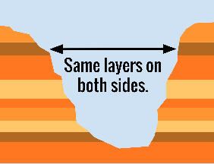
The dark layers are fossil fuels trapped between rock. These layers are plants and animal remains that are very old.

It all starts with plants. Plants must soak up sunlight in order to make food. Plants from long ago soaked up sunlight and stored the energy inside their bodies. When animals ate the plants, it turned into a different kind of energy. When the plants and animals died, they were covered by sand and soil. Over millions of years, the pieces of sand and soil were pressed together and made solid rock.
The leftover parts of the plants and animals were stuck in the solid rock and became fossils. Lots of time, heat, and pressure changed the remains. They became oil, coal, and natural gas. This is why oil, coal, and natural gas are called fossil fuels. There is a limited amount of fossil fuel inside the Earth. Once it is used up, there is no more. This is why fossil fuels are nonrenewable resources.
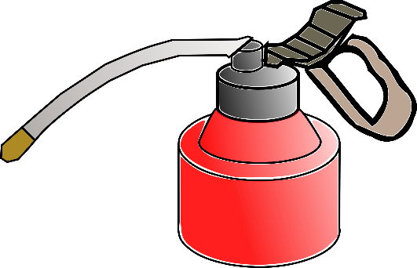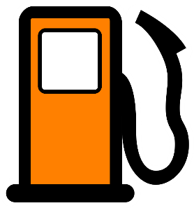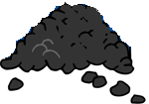
Oil, gas, and coal are fossil fuels. They are nonrenewable which means there is only so much of it in the world. Once it is used up, there is no more.

- Describe how fossil fuels are made. __________________________________________________________________________________________________________________________________________________________________________________________________________________________________________________________________________________________________________________________________________________________________________’
- What does nonrenewable mean and how do you know?
_________________________________________________________________________________________________________________________________________________________________________________________________________________________________________________________________________________

- Gasoline is made using fossil fuels. Many people use gasoline to power their cars every day. Why is it a problem that fossil fuels are nonrenewable? ____________________________________________________________________________________________________________________________________________________________________________________
- Dinosaurs left behind fossils of their bodies in the Earth. What does this have to do with fossil fuels? ______________________________________________________________________________________________________________________________________________________________________________________

