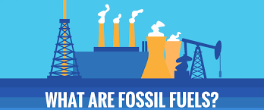
Fossil Fuels: What is it and where did it come from?

Why are fossil fuels important?

Machines, such as the televisions, cars, and computers we take for granted in our daily lives, also need energy to run. Many times the energy used to power these things comes from "fossil fuels." We burn natural gas, a fossil fuel, to heat our homes. We use gasoline, a product made from a liquid fossil fuel named "petroleum," to power our cars. We get energy for our bodies when we eat food or for our cars when we burn fossil fuels.

Let’s start out with a riddle: What does a dinosaur have to do with the lights and heat of your home?
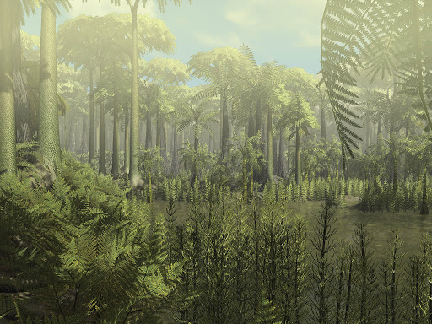
Energy again! The dinosaur ate and used food as fuel to produce the energy it needed to move, play, and even sleep. Our bodies need energy for the same reasons. however, we need energy also to power many things that we use in our everyday life, such as the lights that help us see at night. The energy that makes your lights possible is called electricity. This electricity is produced mostly from fossil fuels that were formed from plants and animals that lived and died millions of years ago. Much of our electricity is produced by burning a fossil fuel rock called "coal." Coal is a very, very old type of fossil. It was formed from plants that flourished in the great swamp forests over 300 million years ago. The Earth's climate, soil, and atmosphere were favorable for thick plant growth. Many large areas of flat swampy land of perpetual summer (because the Earth was MUCH warmer then and much of the land mass was near the equator) existed where plants grew profusely, died, and fell into the shallow waters. These plants could be enormous. Plants that today occasionally grow to three feet in tropical forests, grew to heights of 30-125 feet (impressively tall oak trees today are 100 feet tall). Some of these plants had branches that grew directly out of their trunks making them look like 100 foot tall bottle brushes. over millions of years these dead plants became coal. Anthracite coal can be over 100 million years older than a dinosaur fossil.

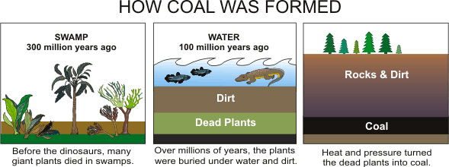
What are fossil fuels?
Fossil fuels are fuels that we use in order to power our lives. Fossil fuels come in three different forms: oil, coal, and natural gas. Fossil fuel use exploded in the industrial revolution when people realized that coal can be used to power equipment. Before the discovery of this hard, black rock that kept burning, people would use wood to cook food and to keep warm. The problem with wood is that it burns quickly. The supply of wood needs to be replenished often when having a fire. Then about 4000 years ago in China, someone discovered that a hard, black rock kept burning for a long time and it was really hot! It stayed warm and did not need to be replenished nearly as quickly as wood. This was coal.

How are they made? Where do they come from?
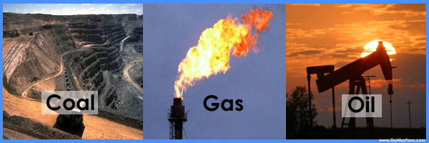
Fossil fuels formed in the Earth hundreds of millions of years ago. Fossil fuels are called fossil fuels because they are created from long dead organic matter. Organic in this instance means something that is carbon based and used to be alive. Anything that is alive or used to be alive, has the element carbon in it. Once that organic matter dies, some of it decomposes and it sinks into mud and rock. Over time many layers of rock build up and over a very long period of time, along with more layers of rock, heat and pressure, turns into a fuel that we can use. All fossil fuels come from the periods in Earth's history when the Earth had huge tropical forests. In those periods, plants lived, grew and died, faster than they decayed. In other words, they were times when much of the dead vegetation did not entirely decompose. Because it did not entirely decompose, it turned into a rock….coal. Coal came from plants. Petroleum and natural gas came mainly from microscopic organisms such as algae.

What are they used for?
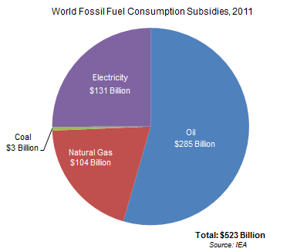
Most of the fuels people burn are fossil fuels. A big use is to make electricity. In power plants fossil fuels, usually coal (but in our area, it is mostly natural gas), are burned to heat water into steam, which pushes a fan-like object called a turbine. When the turbine spins around, magnets inside the turbine make electricity.
Crude oil can be separated to make various fuels such as gasoline, kerosene, jet fuel, and diesel fuel. These substances are made in an oil refinery. They are the main fuels in transportation. That means that they are burned in order to move cars, trucks, ships, airplanes, trains and even spacecraft. Without them, there wouldn't be much transportation.
People also burn fossil fuels to heat their homes. They use coal less for this than they did long ago, because it makes things dirty. In the northeast, most homes are heated by burning oil or natural gas.
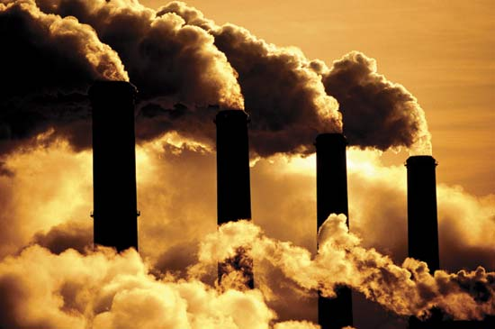
What are some problems with fossil fuels?
Most air pollution comes from burning fossil fuels. This can be reduced by making the combustion process more efficient, and by using various techniques to reduce the escape of harmful gases. When petroleum (oil) and coal burn, they release harmful gases. These gases react with moisture to create acid rain, a dangerous form of pollution. Burning of fossil fuels is also responsible for causing the earth to get warmer. This is climate change. Climate change has been happening since the beginning of time. With the burning of fossil fuels for the past 300 years, we are speeding up that process. Another problem is that they are also non-renewable resources, meaning there is only a limited amount of coal, gas, and oil, and it is not possible to make more quickly. Since the fuels were made from prehistoric forests with tons of organic material and the Earth does not look like that anymore, the Earth is still producing some of these fuels but not nearly at the pace it was millions of years ago.

Check for understanding:
- How were fossil fuels made?

- What are the three types of fossil fuels?

- What are two problems associated with fossil fuels today?

- What can oil be turned into that we used everyday?

- What is the difference between prehistoric forests and today’s forests?

- In terms of the Earth, what does organic matter mean?

- If oil and natural gas were mainly created from algae, what conclusions could you make about the surface of the Earth millions of years ago? (hint: where does algae live?)

- Research your life: What type of heat does your house use? Electricity, oil, or natural gas?

- What are five activities you do daily that require the use of fossil fuels?

- What are five activities that you can do daily to lessen how much fossil fuels energy you use?

